Title of the chapter
List the author names here
Type the author addresses/full affilation here
author’s official e-mail address here
Abstract
All articles must contain an abstract. The abstract text should be formatted using 12 point Times or Times New. Leave 10 mm space after the abstract before you begin the main text of your article, starting on the same page as the abstract. The abstract should give readers concise information about the content of the article and indicate the main results obtained and conclusions drawn. The abstract is not part of the text and should be complete in itself; no table numbers, figure numbers, references or displayed mathematical expressions should be included. It should be suitable for direct inclusion in abstracting services and should not normally exceed 100-200 words in a single paragraph. Since contemporary information-retrieval systems rely heavily on the content of titles and abstracts to identify relevant articles in literature searches, great care should be taken in constructing both. Length of the chapter 25 pages (11550 Words (approx.)) including references

Introduction
These guidelines, written in the style of a submission to J. Phys.: Conf. Ser., show the best layout for your paper using Microsoft Word. If you don’t wish to use the Word template provided, please use the following page setup measurements. Holland [1] introduced the concept of Learning Classifier Systems. Later in the year 1988, a guest editorial was written by Goldberg and Holland [2] which describes the utilization of Genetic Algorithms and Machine Learning. In the same editorial, they have also explained the Genetic algorithms and classifier systems with a significant set of references.

Section
Several tools are available to describe the learning classifier system. In this chapter, the author would like to describe the MATLAB® Classification Learner App, BigML®, and Microsoft® AzureML®. In this text, the author has used these tools wherever it is applicable to impact the output of the classifier system.

1.2.1 Sub-Section
The Classification Learner app of MATLAB® trains models to classify data through a diverse set of classifiers to examine supervised machine learning.

1.3.2 Subsection
Please ensure that affiliations are as full and complete as possible and include the country. The addresses of the authors’ affiliations follow the list of authors and should also be indented 25 mm to match the abstract. If the authors are at different addresses, numbered superscripts should be used after each surname to reference an author to his/her address. The numbered superscripts should not be inserted using Word’s footnote command because this will place the reference in the wrong place—at the bottom of the page (or end of the document) rather than next to the address. Ensure that any numbered superscripts used to link author names and addresses start at 1 and continue on to the number of affiliations. Do not add any footnotes until all the author names are linked to the addresses. For example, to format Fig. 1.1(a) shows the graph of 61 response classes of original dataset and Fig. 1.1(b) shows eight response classes after rounding-off the values in Chance of Admit col- umn from the original dataset. This alteration of data has been done in order to understand the classification learner problem.
Figures: (a) Submit all artwork as separate individual files. You should export or save any graphics in any one of the following formats: EPS, PDF, WMF, TIFF, GIF, JPEG or BMP. (b) All figures must be supplied as final artwork at suitable resolution. Line drawings: 600dpi and saved in two colour mode. Halftones or photographs: between 150 and 300 dpi. Screen captures: At highest resolution possible, usually 96dpi. Colour images: between 150/300dpi and saved with a maximum of 256 colours.

Table 6.6 Number of cars in parking lot
 | 9 a.m. | 11 a.m. | 1 p.m. | 3 p.m. | 5 p.m.
Red | 10 | 2 | 7 | 9 | N/A
Blue | 12 | 12 | 10 | 11 | N/A
Green | 6 | 7 | 4 | 6 | N/A
Silver | 4 | 3 | 4 | 3 | 4
White | 14 | 14 | 13 | 14 | 11

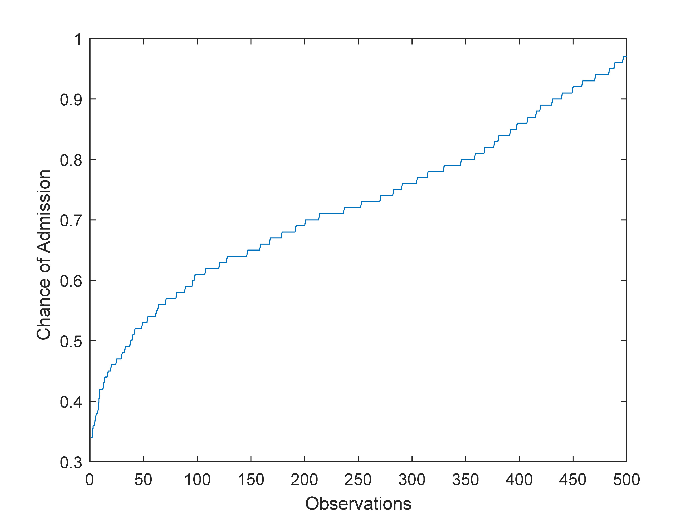 | 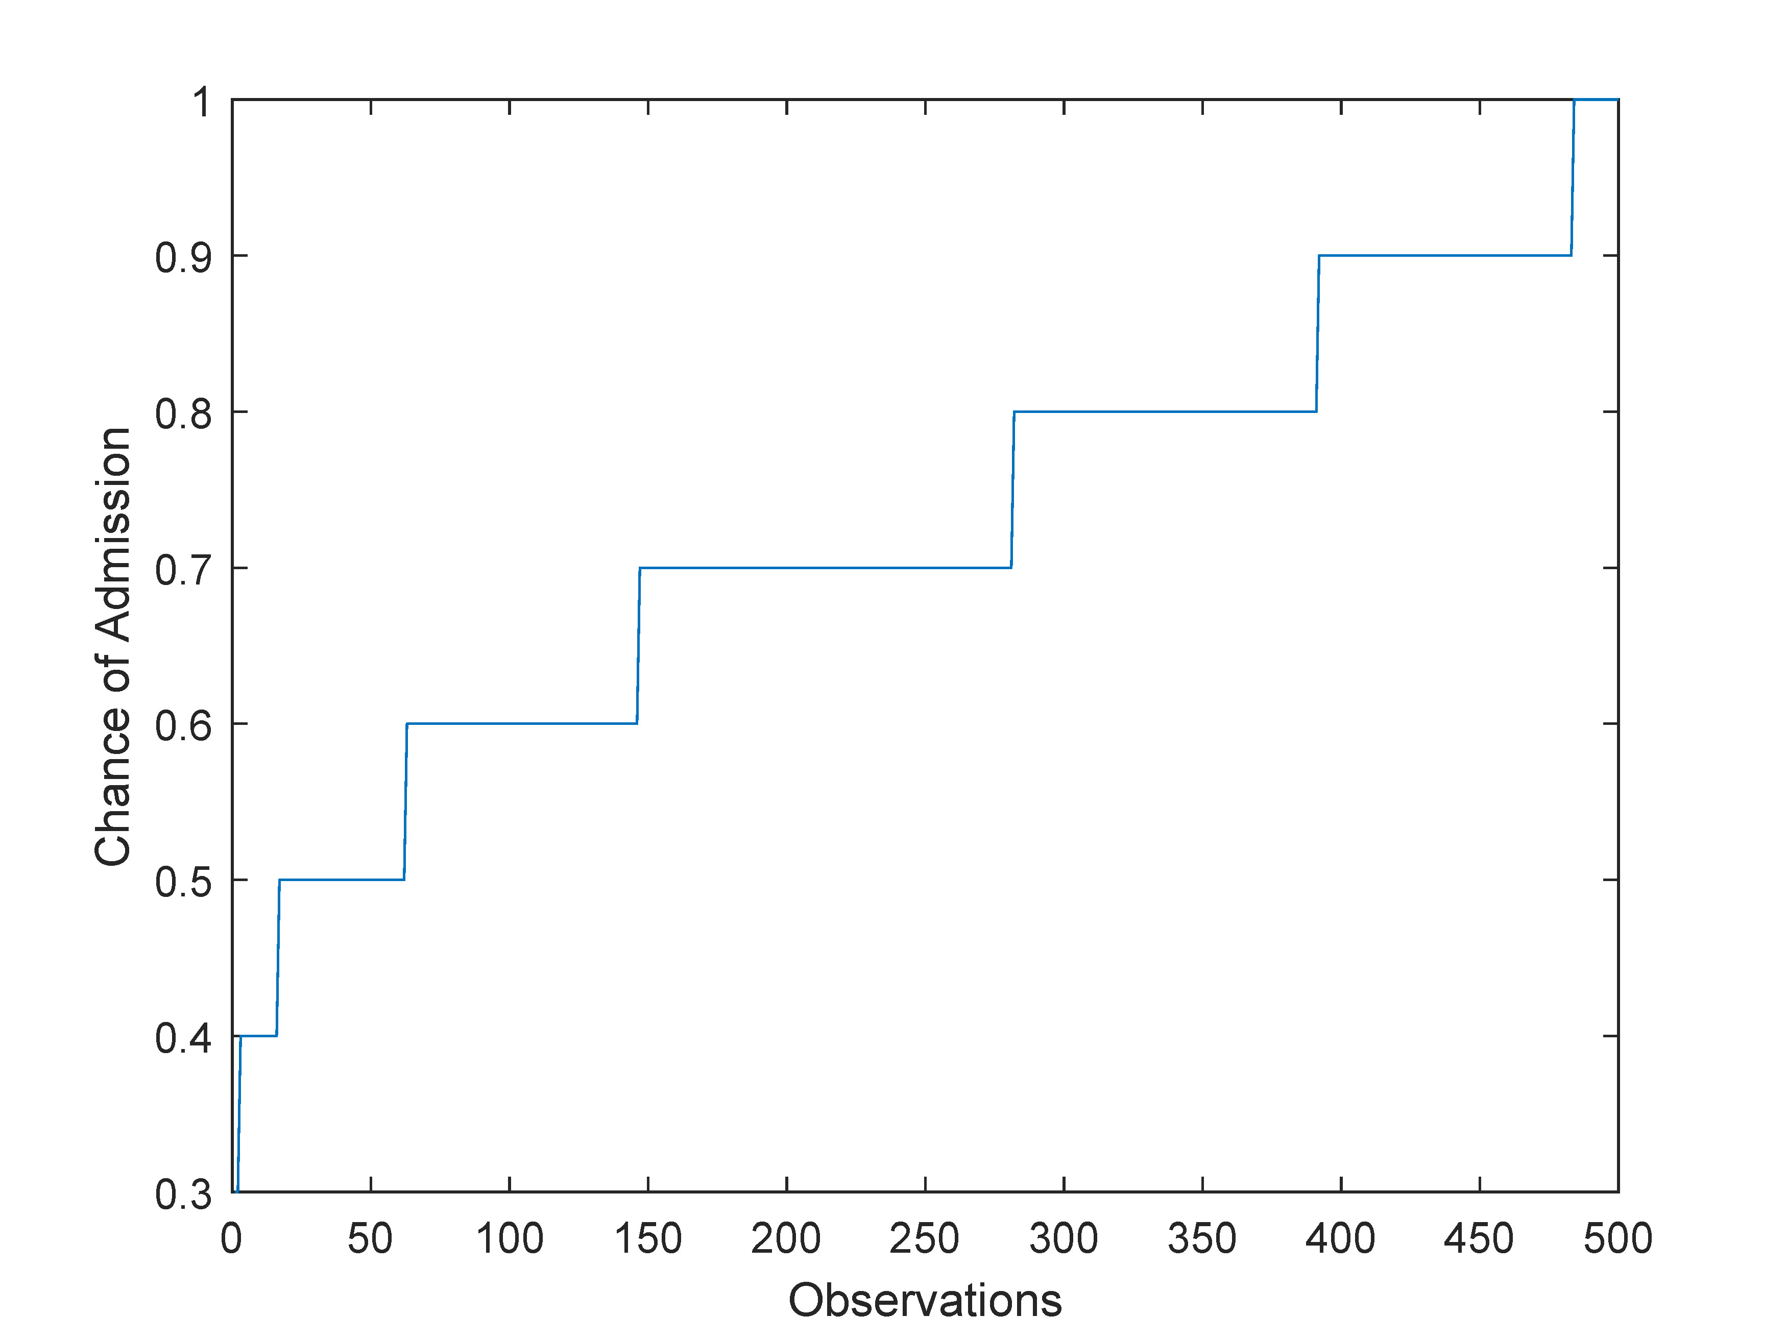
(a) Original Dataset. | (b) Simplified Dataset.
Figure 1.1: Sample of Figure (a) 1 classes (b) 2 classes.
Alt Text: Variation of Chance of Admission for different observaions in the original dataset and simplified dataset.

1.4 Conclusion
Displayed equations should typed on their own line
(1.1)
and un-numbered, unless they are referred to in the text: Where equations are referred to in the text, like tables and figures, should be numbered serially in Arabic numerals through each chapter (e.g. equation (1.1), equation (1.2), . . . where the first number is the chapter number). Equations should be referred to in the text by number, including the braces, e.g. equation (1.1), equation (1.2) etc.

Acknowledgements: Authors wishing to acknowledge assistance or encouragement from colleagues, special work by technical staff or financial support from organizations should do so in an unnumbered Acknowledgments section immediately following the last numbered section of the paper.

REFERENCE STYLES

CRC Press/Taylor & Francis follows Chicago Manual of Style, 16th edition for reference style. However, as long as consistent style is maintained within any one work, logical variations are acceptable (please notify us if you are using a style other than Chicago Manual of Style, 16th edition so we can ensure it is retained). Used numbered citation as [1], [1-3] in text while citating the article. Common reference uses for the Chicago Manual of Style, 16th Edition are below.

CHICAGO MANUAL OF STYLE (16th Edition)

Authored book: Woods, D. D. and E. Hollnagel. 2012. Joint cognitive systems. Boca Raton: CRC Press/Taylor & Francis.

In text: (Woods and Hollnagel 2012)

Chapter in multi authored book: Wiens, J. A. 2005. Avian community ecology: An iconoclastic view. In
Perspectives in ornithology, ed. A. H. Brush, and G. A. Clark, 355–403. Cambridge: Cambridge Univ. Press.

Note: In Reference section, when there are more than six authors, first three are listed, followed by et al. In text, first author listed followed by et al.

Journals: Terborgh, J. 2009. Preservation of natural diversity. BioScience 24:715-22.

Electronic journal: Testa, B., and L. B. Kier. 2013. Emergence and dissolvence in the self-organisation of complex systems. Entropy 2, no. 1 (March): 1-25. http://www.mdpi.org/entropy/papers/e2010001.pdf.

Unpublished Documents:

Schwartz, G. J. 2012. Multiwavelength analyses of classical carbon-oxygen novae. PhD diss., Arizona State Univ.

O’Guinn, T. C. 2014. Touching greatness. Paper presented at the annual meeting of the American Psychological Association, New York.

Online Documents:

Adamic, L. A., and B. A. Huberman. 2006. The nature of markets in the World Wide Web. Working paper, Xerox Palo Alto Research Center. http://www.parc.xerox.com/istl/groups/iea/www/webmarkets.html (accessed March 12, 2014).

U.S. Census Bureau. 2013. Health insurance coverage status and type of coverage by sex, race, and Hispanic origin. Health Insurance Historical Table 1. http://www.census.gov/hhes/hlthins/historic/hihisttl.html.

JOURNAL TITLE ABBREVIATIONS
Please refer to the List of Journals Indexed for MEDLINE (http://www.nlm.nih.gov/tsd/serials/terms_cond.html ) for preferred journal abbreviation.

Author biography, and Contributor List (with contact information and affiliations) should follow.
PERMISSIONS AND SOURCELINES
As indicated in your contract, it is each Author, Editor, or Contributor’s responsibility to obtain all necessary permissions for copyrighted material that is appearing in their chapter. Permissions must be obtained from the original copyright holder, usually the original publisher, and depending on the copyright holder may be necessary even if it is your own material. Please refer to the Permissions Guidelines FAQ document provided for answers to questions such as:

- What needs permission?
- Do I need permission for my own material?
- Do I need permission if I alter a figure?
- Is it the form or content of a table that is copyrighted?
- What about government material?

The completed and signed Permission Verification form is required, noting all previously published material that will appear in each chapter. To exclude a proper source line for previously published material implies that the work is your own and entirely original. This is plagiarism and could result in legal action! This form will be provided to you and must be returned with (or prior to) your final submission.

