Face Shield with Temperature Sensing Ability for Frontline Health Workers
¹Firstname Lastname, ²Firstname Lastname, ³Firstname Lastname, ⁴Firstname Lastname
^{1,2,3,4}Chitkara University Institute of Engineering and Technology, Chitkara University, Punjab, India
Abstract—COVID-19 has harmed millions of people including both patients as well as frontline health workers. There is need to protect frontline health workers as they are the backbone of healthcare system. The existing face shields worn by these workers do protect them but lacks in technology intervention. As a result, healthcare professionals are facing one major issue. The utmost issue is to measure their own body temperature at regular intervals as this process needs removal of hand gloves, PPE (Personal protective equipment) kit and face shield. This is really inconvenient and needs a safe and reliable solution. This paper is disclosing an innovative solution by offering a technologically advanced face shield capable of measuring a body temperature without the need of removing a face shield and a PPE kit. This face shield is designed in solid-works and printed within the university premises using a 3D printer. The sensors were then placed inside this 3D printed assembly. This face shield was then handed over for regular use to faculty and students of health sciences. This innovation received positive feedback from the healthcare professionals. The overall mean score of 4.59 out of 5 indicate that this product is worthy in every facet.

Index Terms—COVID-19, Advanced Face Shield, Temperature sensing face shield

introduction
Recently, Coronavirus has caused great damages to the entire human race without any discrimination. Almost every country got affected due to this invisible enemy. Many frontline warriors are helping communities and countries to protect from coronavirus. Doctors and paramedical staff are working tirelessly to control this virus from community transfer. The health organizations including WHO (World Health Organization) are recommending the use of face masks and face shields as a protective measure as they have proved effective in the past(Cook 2020).
The face shields must cover the entire face as this virus spreads from nasal and oral emissions. Most of these face shields are designed keeping this requirement in mind but still they are lacking in one key area which needs to addressed and resolved.
The major issue with the existing face shields is that there is no technological intervention in them. As a result, healthcare professionals are facing one major issue. The utmost issue is to measure their own body temperature at regular intervals as this process needs removal of hand gloves, PPE kit and face shield. This is really inconvenient and needs a safe and reliable solution.This paper is disclosing an innovative solution by offering a technologically advanced face shield capable of measuring a body temperature without the need of removing a face shield and a PPE kit.
This innovation will certainly help doctors and paramedical staff to protect themselves from this hazardous coronavirus by regularly monitoring their body temperature without removing PPE kits or gloves. Monitoring body temperature of health line workers is essential as an infected healthcare worker may become a community spreader.

related work
Several face shields have been designed and manufactured in the past by various researchers and organizations to fight against coronavirus. In most of the researches, the face shields were offered for specific domain areas and professionals. In another study the authors designed a face shield to protect interventional radiologists from droplet transmission of the SARS-Cov-2. Likewise, the authors in designed a face shield for anesthesia providers due to their close contact to patients. In another study, the researches designed an ergonomic 3D face shield to protect against coronavirus. The authors in manufactured a face shield for patients undergoing endoscopy. IIT (Indian Institute of Technology) madras also offered a reusable face shield which allows replacing front transparent shield as and when required. In another research, the face shield was designed for maxillofacial surgeons. Similarly, a group of teachers and students joined together to make a rapidly developed 3D face shield to protect health workers. The authors in also offered a reusable 3D face shield(Amin et al. 2020; Armijo et al. 2021).
The literature disclosed that majority of these face shields were either made of PVC (Polyvinyl Chloride),PETG (Polyethylene Terephthalate Glycol), Polylactic Acid Filaments (PLA), OHP (Overhead Projector) sheets, generic acetate sheets or acrylic material.Only few large and small scale industries used premium PLA profilament, medical grade nylonand ABS-42 for manufacturing face shields. A comprehensive specifications of past innovations in this area have been disclosed in the Table 1.
Table 1. Specifications of existing face shields
Specifications | Year
3D printed face-shield, PVC, Stiff A4/A3 OHP (Overhead Projector sheets) | 2014
3D printed face-shield, PVC, 200-300 μm-thick | 2020
3D printed face-shield, 10 mL thick PVC | 2021
Ergonomic 3D face-shield, 0.3mm PVC | 2021
Acrylic face-shield | 2020
3D printed face-shield, replaceable plastic sheets | 2020
3D printed face-shield, Polylactic acid filaments (PLA) | 2020
3D printed face-shield, Polylactic acid filaments (PLA) and PETG(Polyethylene Terephthalate Glycol) | 2021
3D printed face-shield, Polylactic acid filaments (PLA), no obstruction for stethoscope | 2020
Face-Shield, Generic acetate sheet (used for overhead projectors) | 2020

objectives
This paper is aimed to design a technologically advanced 3D face shield capable of monitoring body temperature of healthcare workers as and when required that too any hassle of removing hand gloves or PPE kits. Another objective is to make this face shields reusable.

methodology
The present disclosure relates, in general, to face shield, and more specifically, relates to a shield worn over the face to monitor the body temperature instantly whenever required. Figure 1 depicts the step by step approach adopted to achieve the objectives.
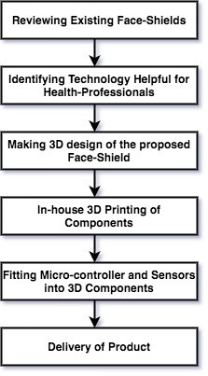
Figure 1. Chronological order of face shield development
The literature was reviewed first to find the specifications of existing face shields. These specifications have been listed in the Table 1. After observing the shortcomings of existing face shields, the team worked on identifying the technology that can be helpful for the healthcare professionals. As a result, a technologically advanced face shield was introduced with built-in capability to sense the body temperature. Thereafter, a 3D design of the face shield was made using SolidWorks software keeping all electronic components in mind. During the design process, the dimensions of electronic components were carefully measured. Some of the dimensions were directly taken from the product manual(Lemarteleur et al. 2021; Nazir et al. 2020).
In the next stage, in house 3D printer was used to print the face shield. The PETG material with infill density of 25% and tensile strength of 38 MPa was finalized as the face-shield material as the value of tensile strength for PETG with infill density of 25% has already been validated previous. The head length and head width of the face shield was also chosen carefully keeping anthropometric dimensions of head of Indian adults. A study in has disclosed the average head dimensions of Indian male and female (see Table 2).

Table 2. Anthropometric dimensions of head of Indian adults
Sr. No | Anthropometric dimensions | Gender | Mean Value
1 | Head Length | Male | 188.82
 |  | Female | 183.69
2 | Head Width | Male | 152.71
 |  | Female | 149.06
3 | Head Circumference | Male | 547.66
 |  | Female | 531.86

As a result, this study kept head length as 186.13 mm and head width as 151 mm. These dimensions are very close to mean dimensions suggested in the Table 2.The 3D design of this face shield is depicted in the figure 2 and figure 3. In the next stage, microcontroller and other sensors were fitted into the face shield assembly and prototype was delivered.

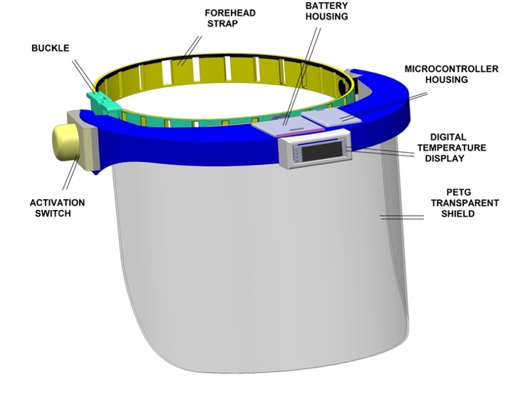
Figure 2. Front-view of face-shield

The electronic components used within this face shield includes microcontroller, infrared temperature sensor, display unit, mini speaker and a battery. Table 3 shows the specifications of these sensors.

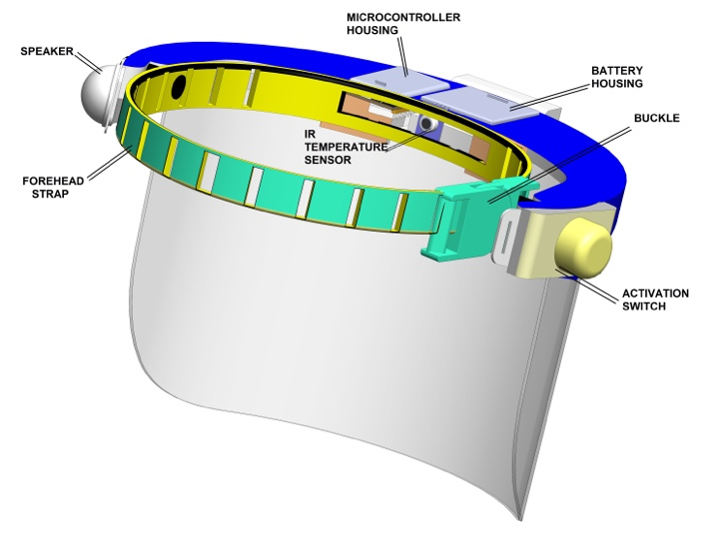
Figure 3. Rear-view of face-shield

Table 3. Electronic components used within face shield
Equipment | Model | Purpose
Microcontroller | ESP32 | It is connected with the infrared temperature sensor
IR Temperature Sensor | MLX90614 ESF | It will sense human body temperature of the health worker.
Display Unit | OLED | This unit will display the body temperature in OLED (Organic Light Emitting Diode).
Battery | Lithium Polymer | It is capable of providing power supply to the whole unit.

This face shield is equipped with ESP32 microcontroller which is capable to connect with Wi-Fi. This microcontroller make this face shield IoT (Internet of Things) enabled. This prototype is also equipped with 600 mAh lithium polymer battery that can supply power for approximately five hours.

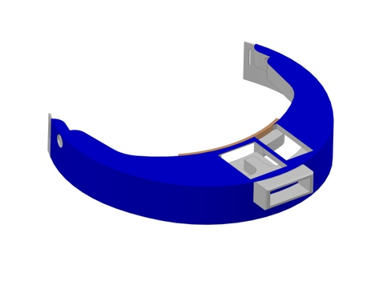
Figure 4. Shield Frame

This face shield is composed of three main components namely shield frame, forehead strap and a transparent shield. All these key components need to be assembled to make a face shield (see figure 4, figure 5 and figure 6). The forehead strap was made of latex-free silicon.
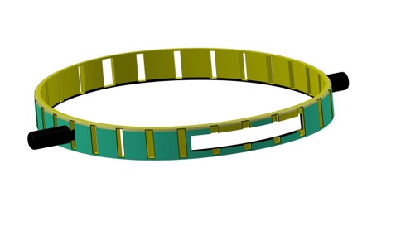
Figure 5. Forehead-Strap

The transparent shield was made with PETG (Polyethylene Terephthalate Glycol) material.

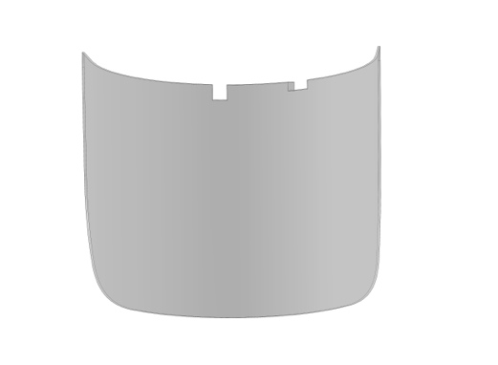
Figure 6. Transparent Front Shield

results
A total of ten such face shields were printed within the university premises. Thereafter, these face shields were handed over to students and faculty of health science department for regular use. Due to limited number of face shields, at a time only ten participants could be participated. Each participant was told to use the face shield for one week only. After one week, these face shields were given to another ten participants. This pattern was repeated four times and as a result forty subjects participated in the study.The participants were also instructed to use Isopropyl alcohol to clean the face-shield before submission. As a precaution, the team of researchers also usedIsopropyl alcohol to clean the face shields before handing over to other participants. The whole study took four weeks to complete.
Thereafter, a questionnaire was shared with all the participants to get the feedback of the face shields. All questions were asked on five point Likert scale (strongly disagree=1, disagree=2, neutral=3, agree=4, strongly agree=5) to measure the overall feedback. This questionnaire holds only seven brief statements to judge the quality and utility of the face shield. The IBM SPSS statistical tool was used to evaluate the feedback. Table 4 shows the descriptive statistics of feedback responses.

Table 4. Descriptive statistics of feedback responses
Questions | N | Mean
Is this product durable? | 40 | 4.45
How easy is to wear and remove this product? | 40 | 4.63
Rate your experience with context to the comfort level. | 40 | 4.60
How easy is to clean this product for reusability? | 40 | 3.93
Can you see properly while using this product? | 40 | 4.90
Are you comfortable in adopting technology used within this product? | 40 | 4.85
Will you recommend this product to others? | 40 | 4.80

Table 4 shows overall mean score of 4.59 out of 5 which indicates that this product is worthy in every facet.

discussion
Due to pandemic, rapid manufacturing is required and as a result 3D printed face shields comes into existence. This research work extended the idea of rapid manufacturing of face-shields using 3D printers by introducing technology into it. Existing face-shields were lacking in this area. The fact is frontline healthcare professionals are more disposed to environment where probability of getting effected from COVID-19 is higher. In such situations, the body temperature of healthcare professional needs to monitored after regular intervals as a safety measure. This would certainly provide a safety to healthcare professionals as well as patients because the disease may be transferred from patients to doctors and vice-a-versa.

Table 5. Measurements of Electronic Components
Sr. No | Equipment | Measurements
1 | Microcontroller | length (mm) 49.5, width (mm) 26.5, thickness (mm) 11.5
2 | Temperature Sensor | Board size(mm) 11.2 x 19.38
3 | Display Unit | Display area 30 mm x 12 mm, length(mm) 38, width(mm) 12, thickness(mm) 11.3mm
4 | Battery | Length: 48mm, width: 24 mm, thickness: 4mm

Due to involvement of electronic components, making a perfect 3D design was challenging as every electronic component needs to be fitted precisely into the face shield housing. Therefore, measurements of electronic devices were crucial. Majority of the measurements were found in the product manual but as a precaution it was measured again with Vernier-Caliper. These measurements are shown in the Table 5.
All measurements are in mm(millimeter). The feedback of this product was crucial. Table 4 shows overall mean score of 4.59 out of 5 which indicates that this product is worthy in every facet.This can be seen in the figure 5.

Figure 5. Feedback Responses

The lowest feedback was regarding cleaning the face shields. The mean value in response to the question “How easy is to clean this product for reusability?” was 3.93 out of 5. It indicates that participants faced issues while cleaning and reusing the face shield. This seems a temporary issue as extensive training programs can resolve this issue.

Conclusion

This technologically equipped face shield is disclosing an innovative solution for the healthcare professional to monitor their body temperature instantly without removing their gloves or face shields. This face-shield got positive reviews in every perspective like durability, easy to wear and remove, comfort level, visibility, technology adoption and willing to recommend to others. The overall mean score of 4.59 out of 5 indicate that this product is worthy in every facet.

This innovation is equipped with MLX90614 ESP sensor which is calibrated in the range -40 to 125ºC for sensor temperature and -70 to 380ºC for the object reference.

The only limitation of this product is difficulty in cleaning the product. It may be resolved after long term usage and proper training. The other limitation is the cost of this product. This face-shield is comparatively costly as compared to existing face-shields due to the deployment of electronic equipment’s like esp32 microcontroller, infrared temperature sensor, display unit and battery. The existing face-shields are merely composed of PETG, PVC or PLA material without any technology intervention and hence cheap but does not achieve real time monitoring of body temperature without removing gloves or face-shields to protect healthcare professionals by diagnosing increased temperature which is one of the key symptoms of COVID-19.

References (Chicago Style)
Amin, Dina, Nam Nguyen, Steven M Roser, and Shelly Abramowicz. 2020. “3D Printing of Face Shields During COVID-19 Pandemic: A Technical Note.” Journal of Oral and Maxillofacial Surgery 78 (8): 1275–78. doi:https://doi.org/10.1016/j.joms.2020.04.040.
Armijo, Priscila R, Nicholas W Markin, Scott Nguyen, Dao H Ho, Timothy S Horseman, Steven J Lisco, and Alicia M Schiller. 2021. “3D Printing of Face Shields to Meet the Immediate Need for PPE in an Anesthesiology Department during the COVID-19 Pandemic.” American Journal of Infection Control 49 (3): 302–8. doi:https://doi.org/10.1016/j.ajic.2020.07.037.
Cook, T M. 2020. “Personal Protective Equipment during the Coronavirus Disease (COVID) 2019 Pandemic--a Narrative Review.” Anaesthesia 75 (7). Wiley Online Library: 920–27.
Lemarteleur, Vincent, Vincent Fouquet, Stéphane Le Goff, Laurent Tapie, Pascal Morenton, Aurélie Benoit, Elsa Vennat, et al. 2021. “3D-Printed Protected Face Shields for Health Care Workers in Covid-19 Pandemic.” American Journal of Infection Control 49 (3): 389–91. doi:https://doi.org/10.1016/j.ajic.2020.08.005.
Nazir, Aamer, Aashir Azhar, Usman Nazir, Yun-Feng Liu, Waqar. S Qureshi, Jia-En Chen, and Eisa Alanazi. 2020. “The Rise of 3D Printing Entangled with Smart Computer Aided Design during COVID-19 Era.” Journal of Manufacturing Systems (in press). doi:https://doi.org/10.1016/j.jmsy.2020.10.009.
Note: You can use Mendeley for referencing style (Chicago Style)

